  - Name: Soniya Eknath Girhe. Sec_Batch_RollNo.: A7_B3_59.
  - Date:17/03/2026.

Practical 05

Aim
To study and implement the concept of array of objects in Java by designing a Student
Record Management System that stores, displays, searches student details, and calculates average marks using object-oriented programming principles.

Code:
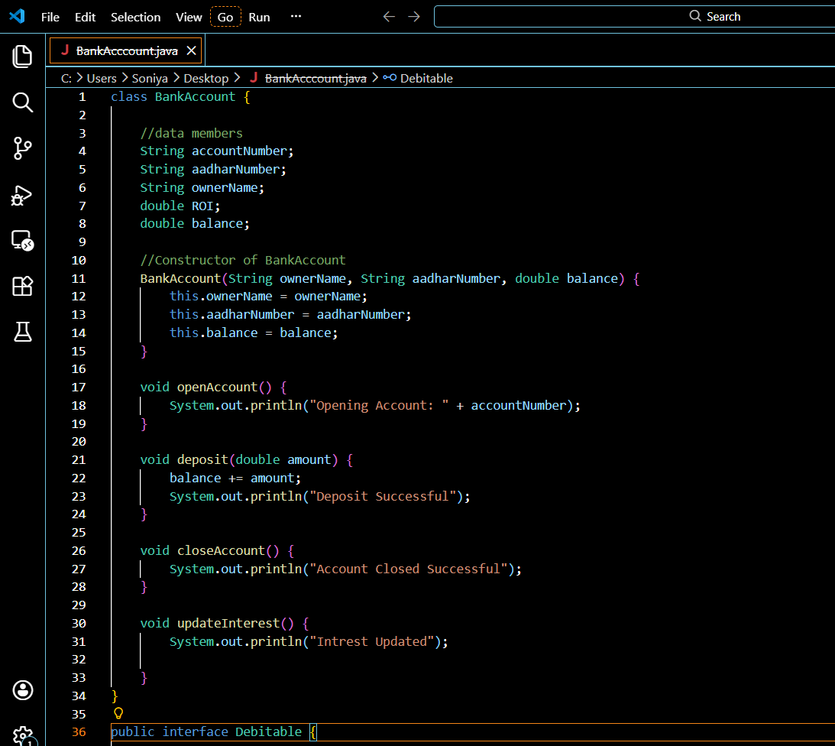
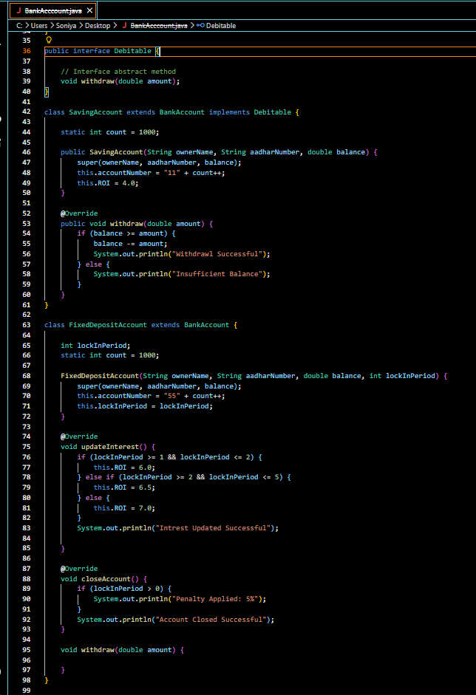
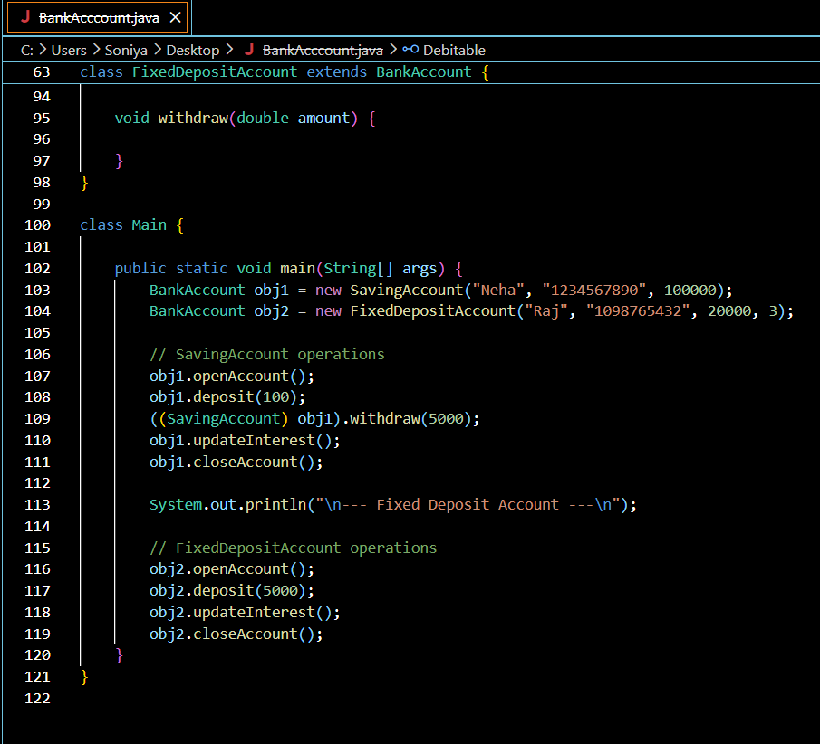

Output:
